**Project Initialization and Planning Phase**

| Date | 9 JULY 2024 |
| --- | --- |
| Team ID | 739880 |
| Project Name | Forecasting Economic Prosperity:  Leveraging machine learning for  GDP per Capita Predicition |
| Maximum Marks | 3 Marks |

**Define Problem Statements (Customer Problem Statement Template):**

To develop a machine learning model that accurately predicts GDP per capita for a given country based on historical economic indicators and relevant socio-economic factors.

• Economic prosperity, as measured by GDP per capita, is a critical indicator of a country's overall economic health and living standards.

• Accurate forecasting of GDP per capita enables policymakers, economists, and investors to make informed decisions regarding economic policies, investments, and resource allocations.

**Example:**

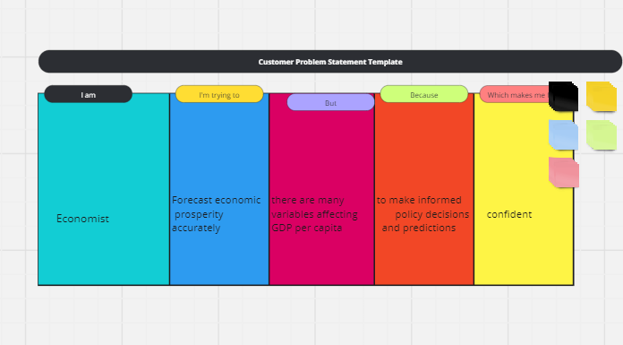

|  |  |  |  |  |  |
| --- | --- | --- | --- | --- | --- |
| **Problem**  **Statement (PS)** | **I am**  **(Customer)** | **I’m trying to** | **But** | **Because** | **Which makes me feel** |
| PS-1 | Economist | Forecast economic prosperity accurately | there are many variables affecting GDP per capita | to make informed policy decisions and predictions | confident in my economic analyses |
| PS-2 | Investor | Predict GDP per capita trends | traditional methods have limitations in accuracy | to make sound investment decisions | confident in my investment strategies |